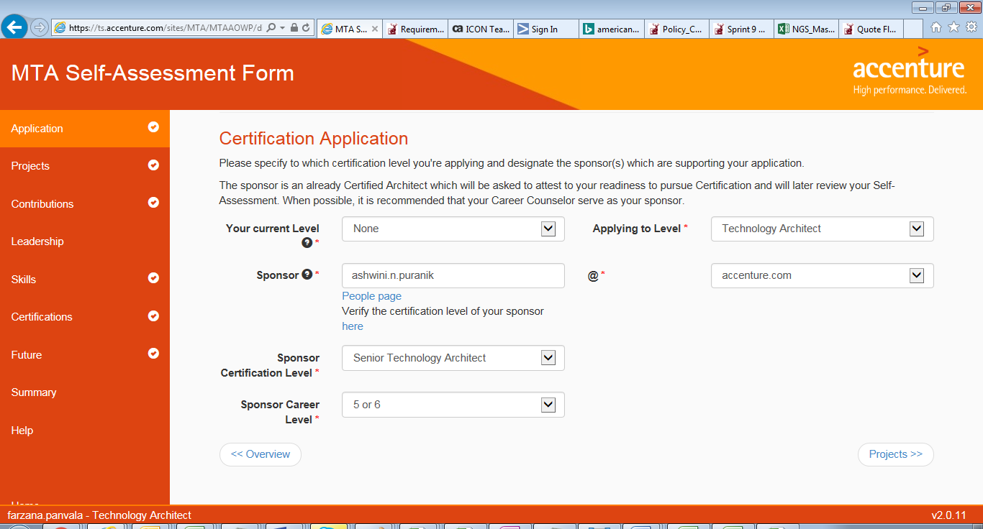

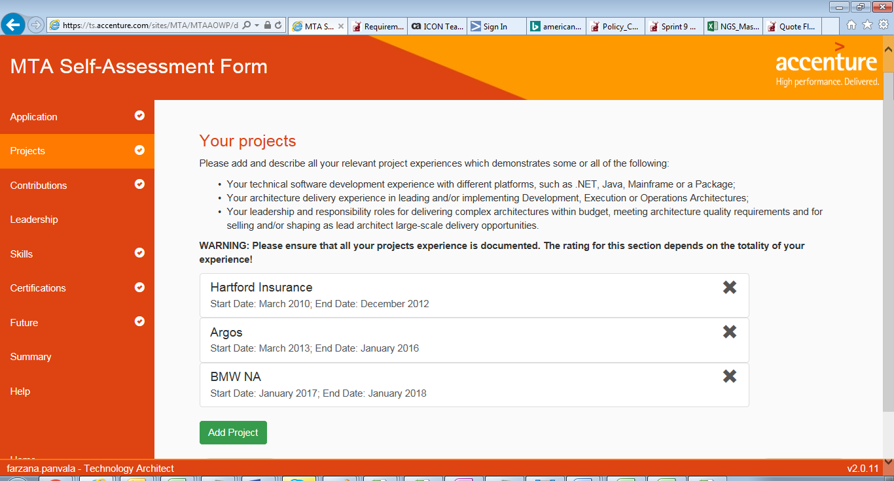

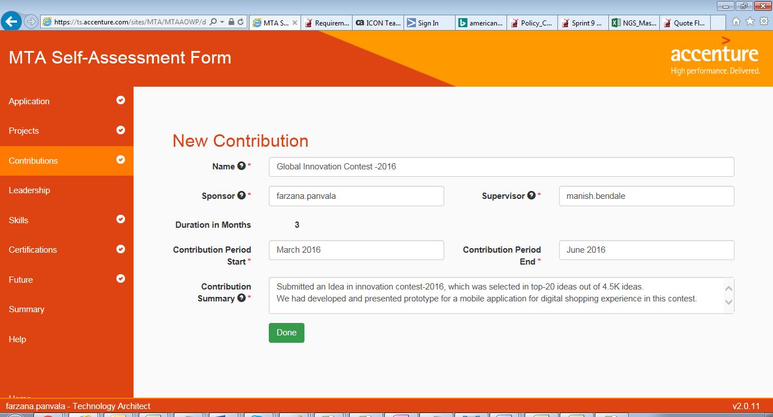

[MANIK] – Add more on contribution eg: participation to GHCI , any internal brownbag sessions conducted by you for team, trainings , KX material , submission to reusable liberary (ARTL) etc

Incase u don’t have try to submit your point of view on KX site – this is quick one and can get u some brownie points.

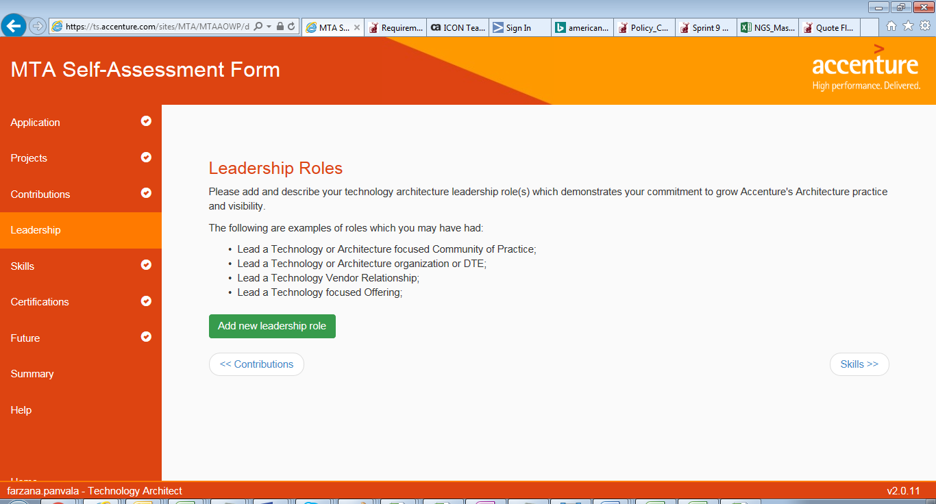

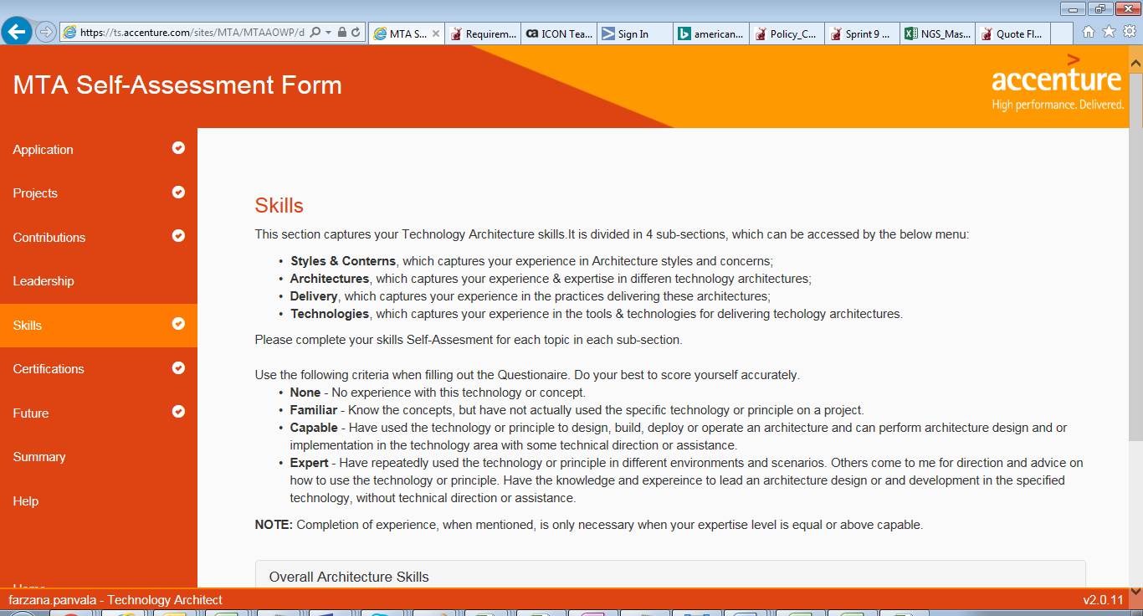

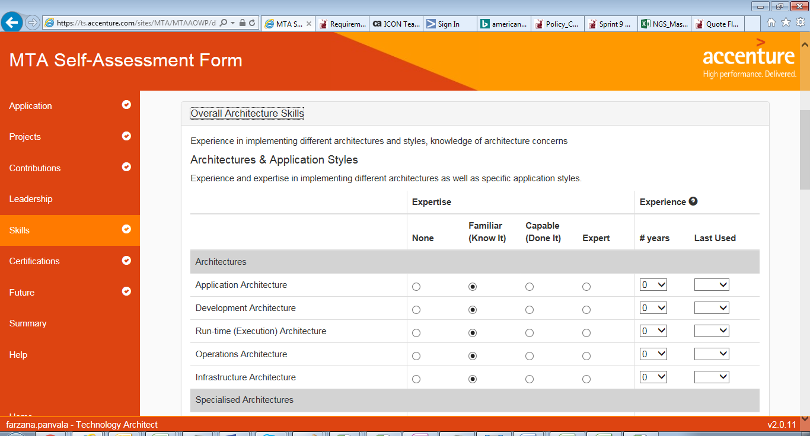

[Manik] Application , Development, Run-time, Integration architecture is something we use all the time in every delivery project – mark it as expert level

Operations ,Data, Security -capable

Cloud – if using it mark it capable else familier

Infrastructure – incase u have knowledge of cloud & enterprise solution ,mark it capable else familiar

NOTE :FOR EVERY ROW U MUST ADD YRS OF EXP AND LAST USED IT CAN”T BE BLANK

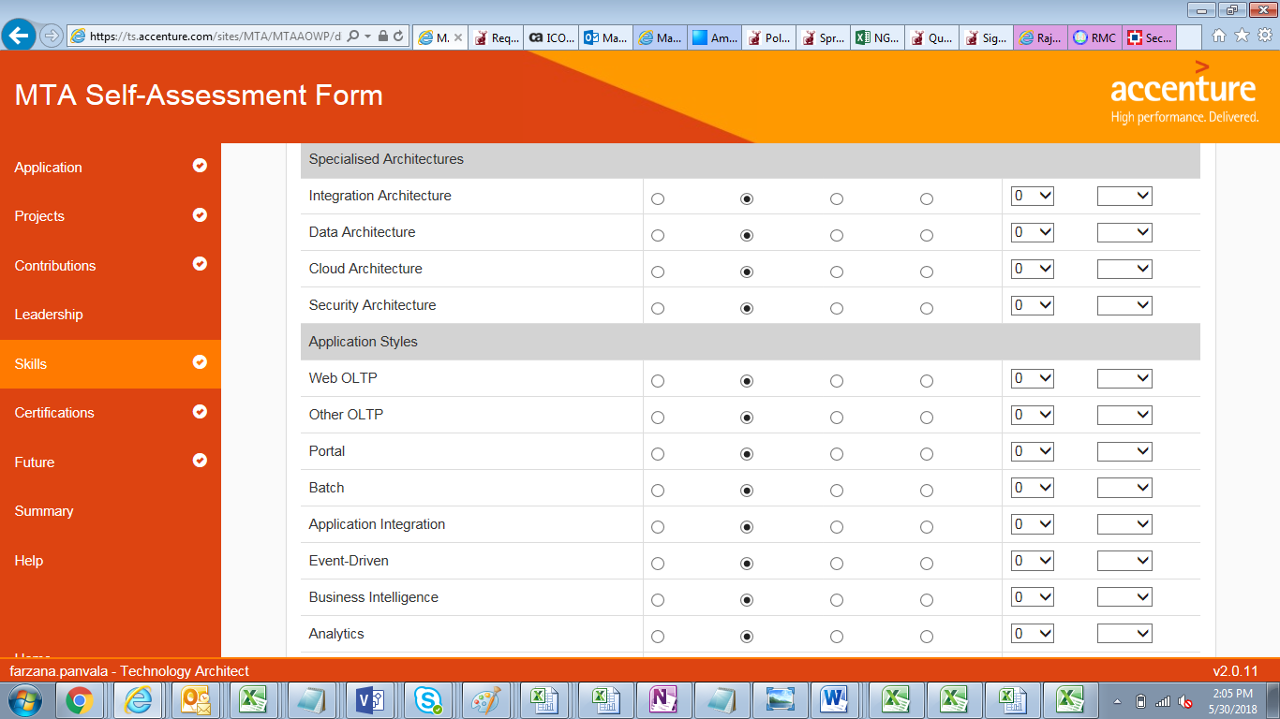

[Manik] All the application styles must be known to you mark it expert also read about it (incase not aware of )they are very easy concepts.

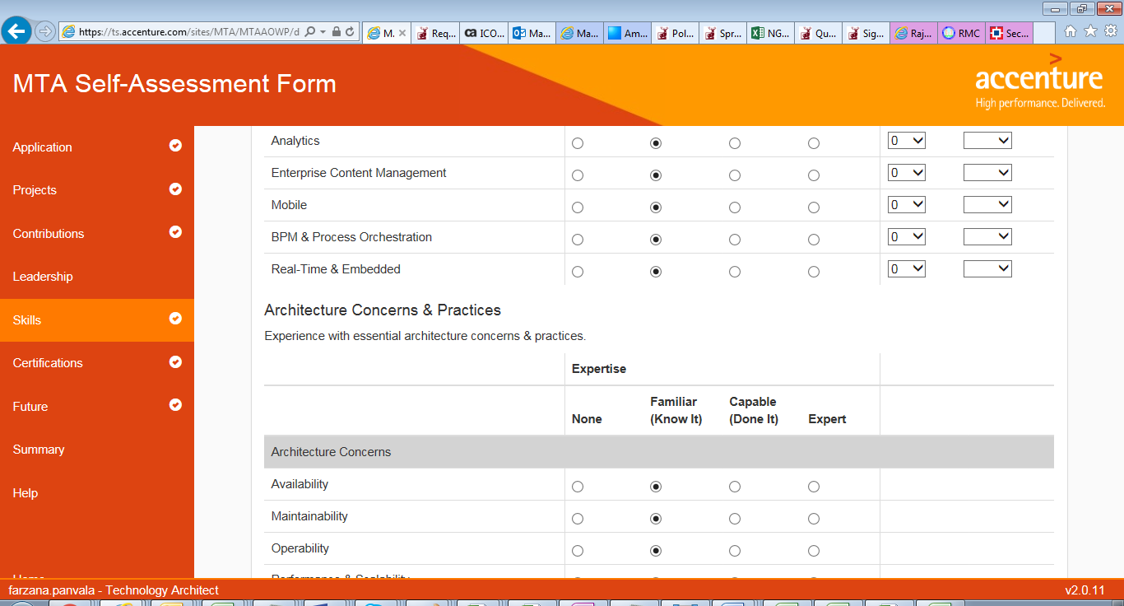

[Manik] Bring the architecture concerns level to capable by gathering information with your counterparts on how it is managed in ur current project .. level should be capable..

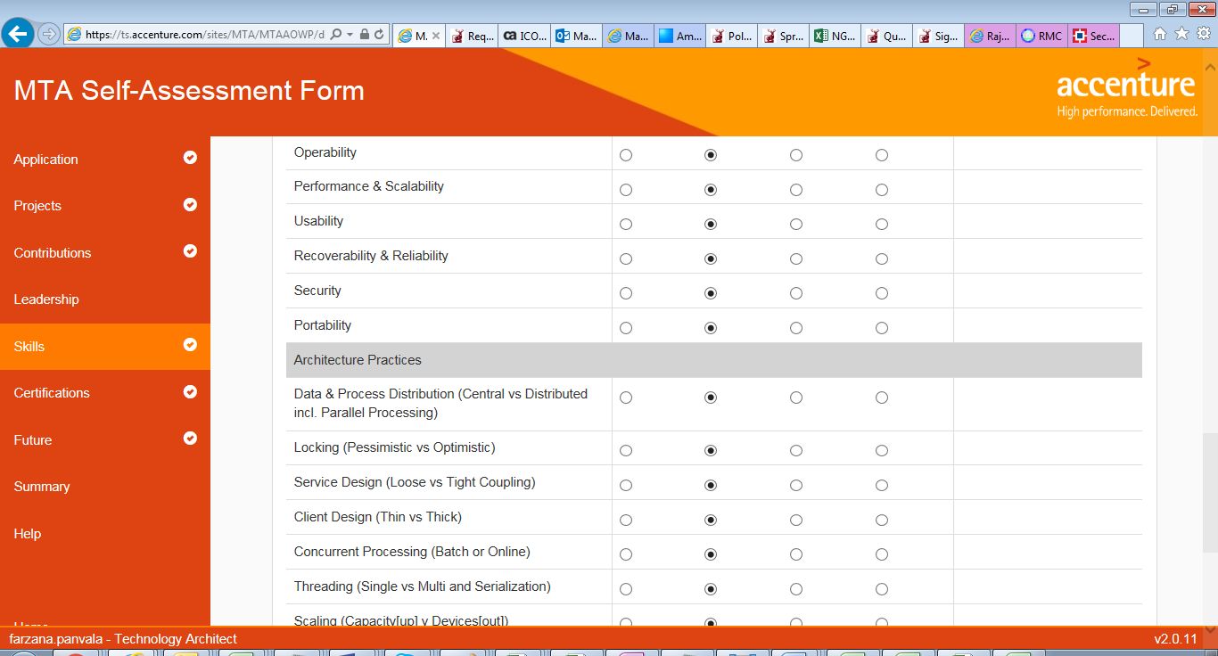

[Manik] locking , service design, client design , concurrent processing, threading 🡪expert

Rest should be capable. (read and prepare about it incase u don’t know)

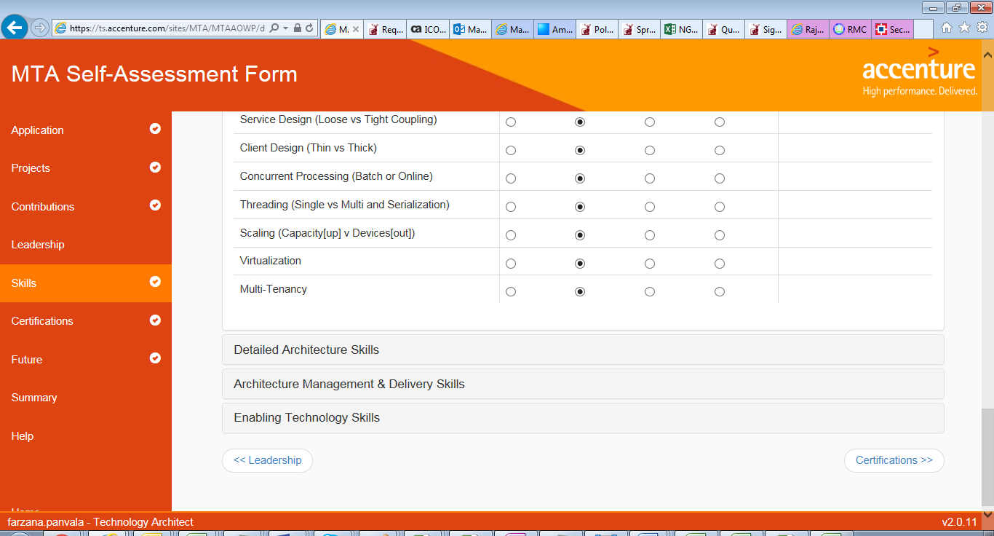

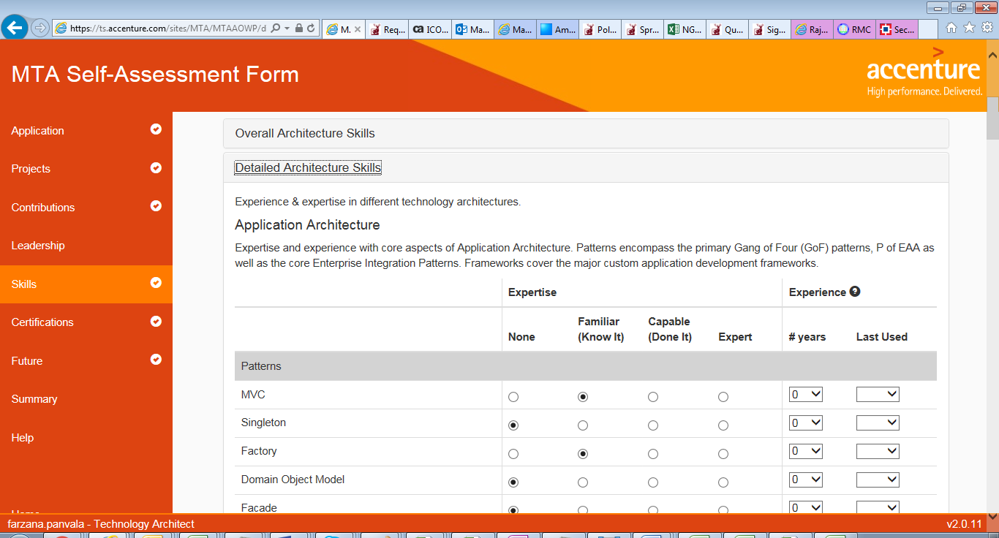

[Manik] – this all should be expert level – design pattern read GOF

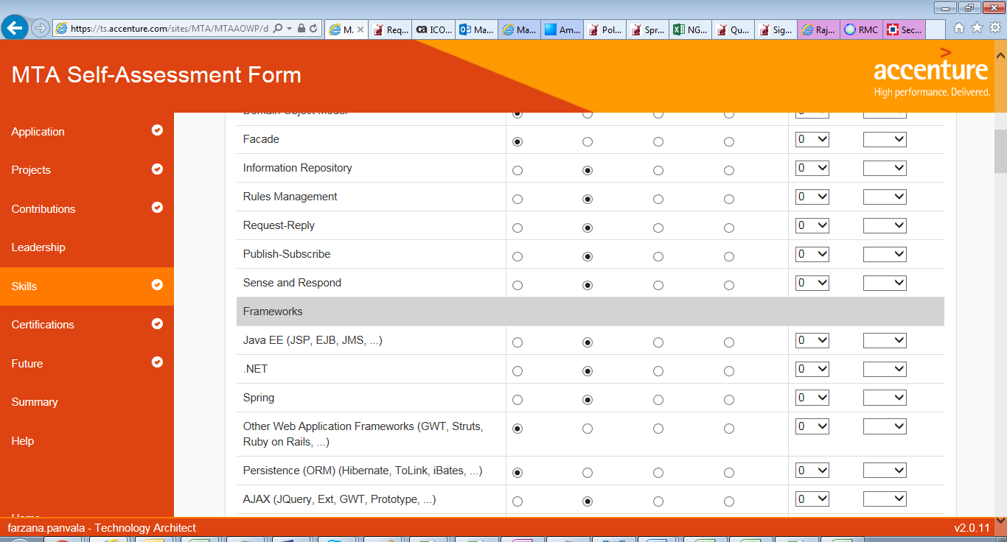

[Manik] frameworks (custom frameworks like Java EE , web Application frameworks , persistence , Ajax ) should be expert if from java background .

Incase not from custom/Java development background – level should capable

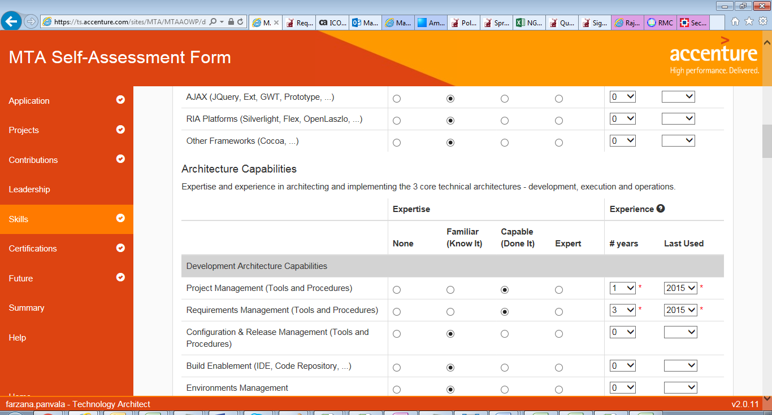

[Manik] – Architecture capabilities should be expert, you can read about it on Accenture DEX site.

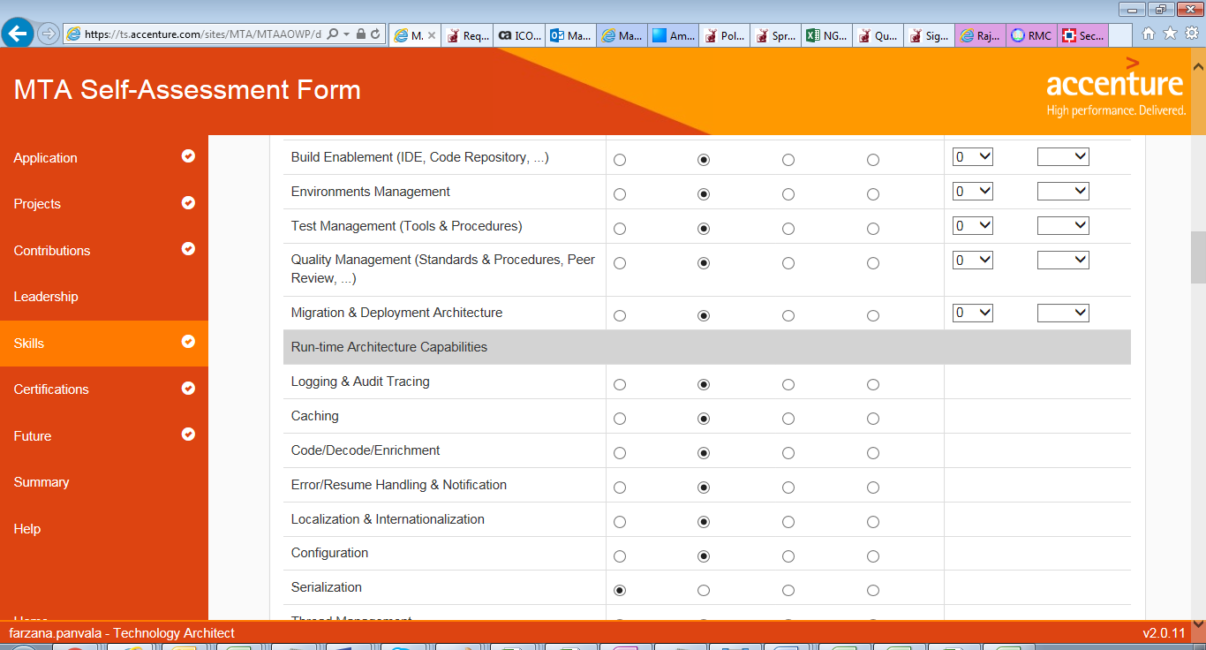

[Manik] Operation Architecture capabilities should be capable level atleast.

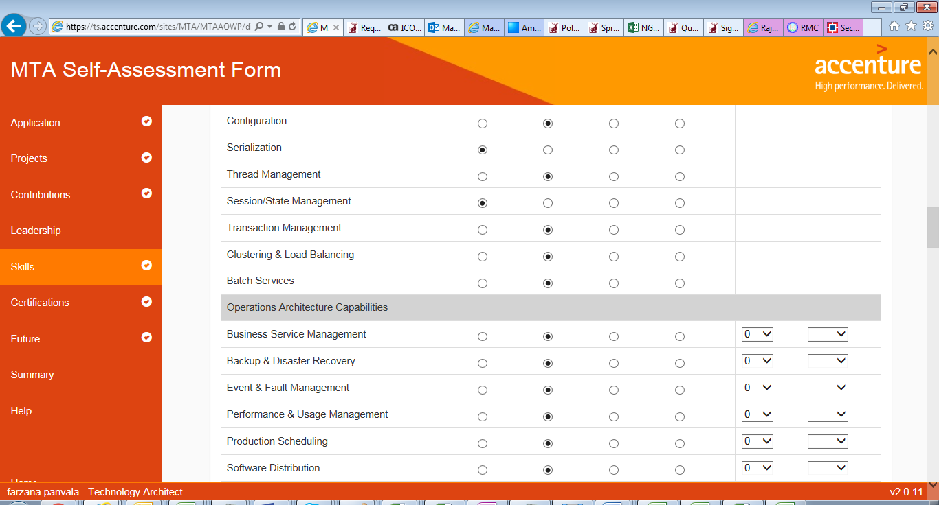

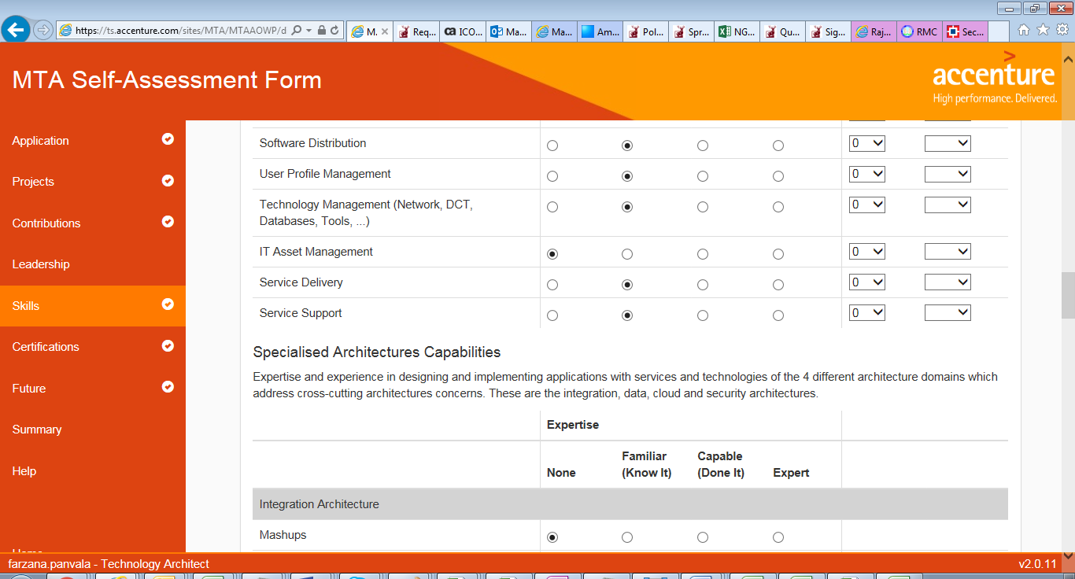

[Manik] specialized Architecture capabilities should be at level capable ( few) but mostly at expert level

Anything u don’t know at the moment – just read it from google and prepare prior taking interview.

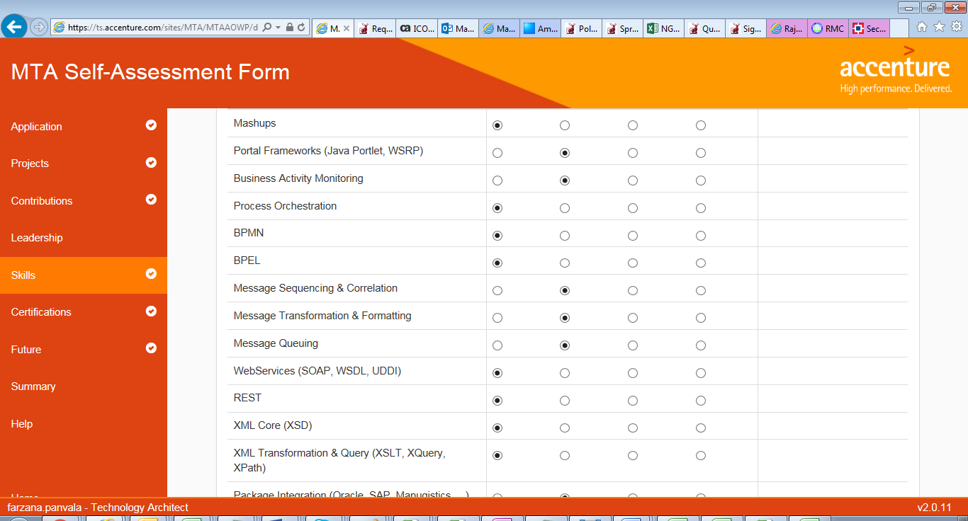

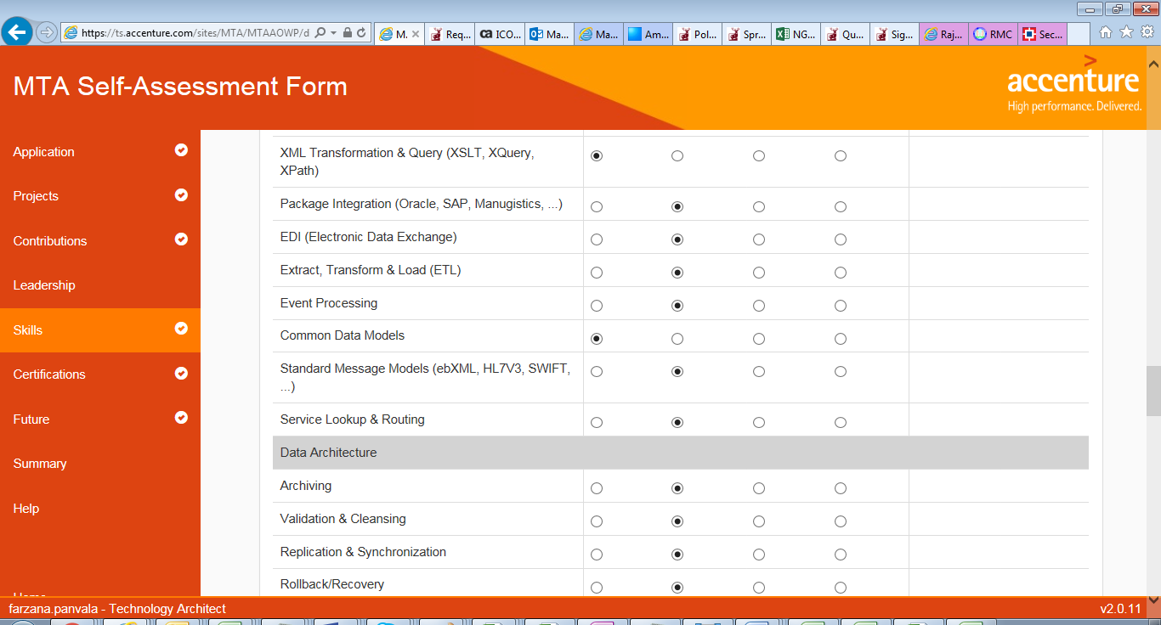

[Manik] Data Architecture capabilities should be at level capable ( few) but mostly at expert level

Anything u don’t know now – just read it from google and prepare prior taking interview.

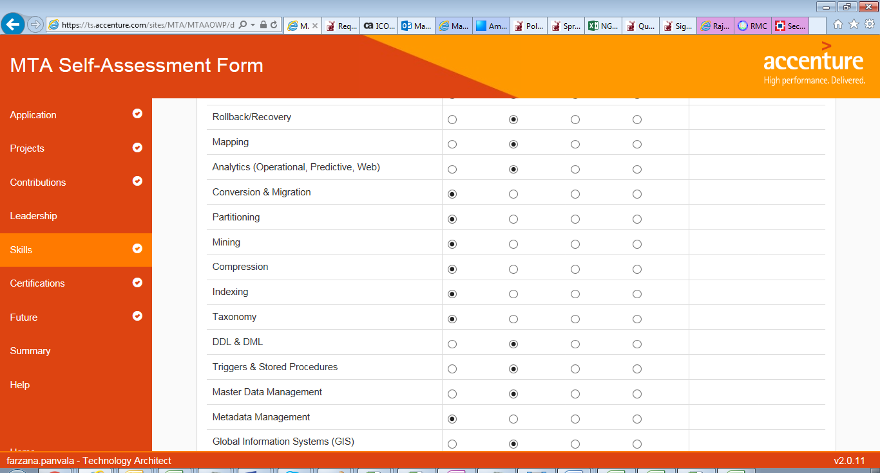

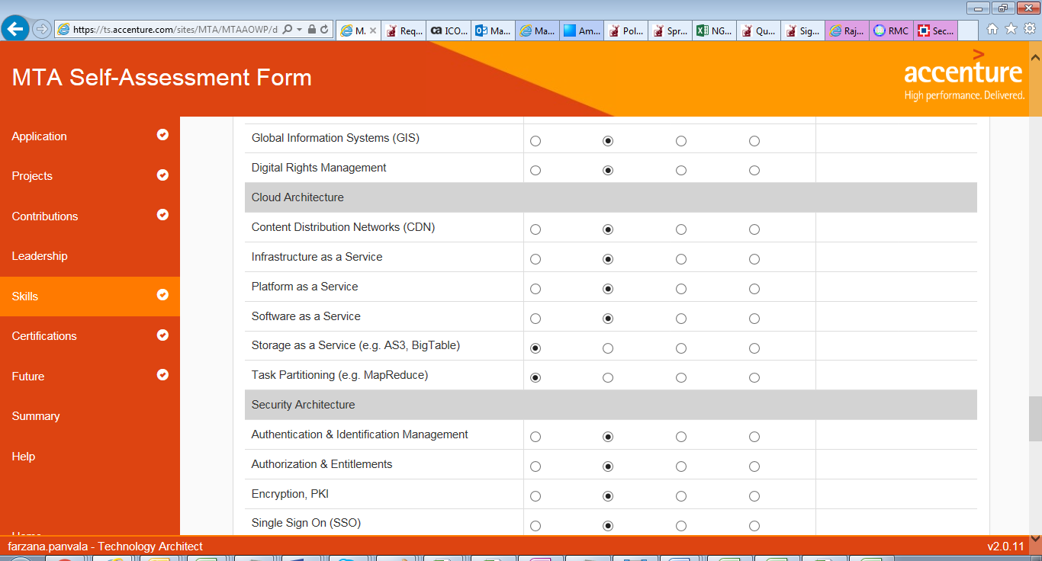

[Manik] specialized Architecture capabilities should be at level capable ( few) but mostly at expert level

Anything u don’t know at the moment – just read it from google and prepare prior taking interview.

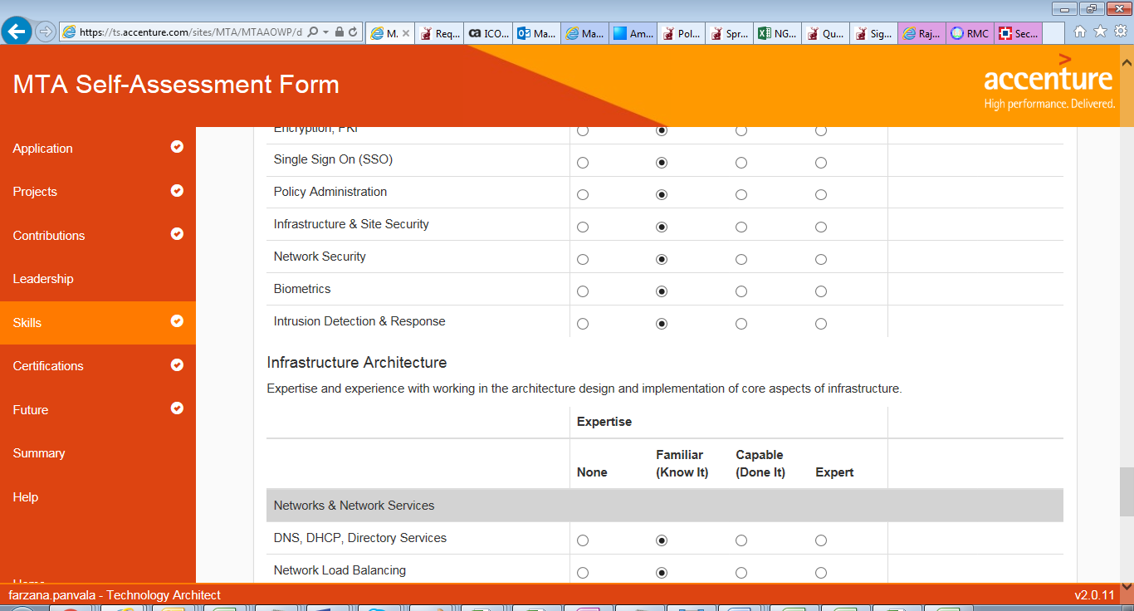

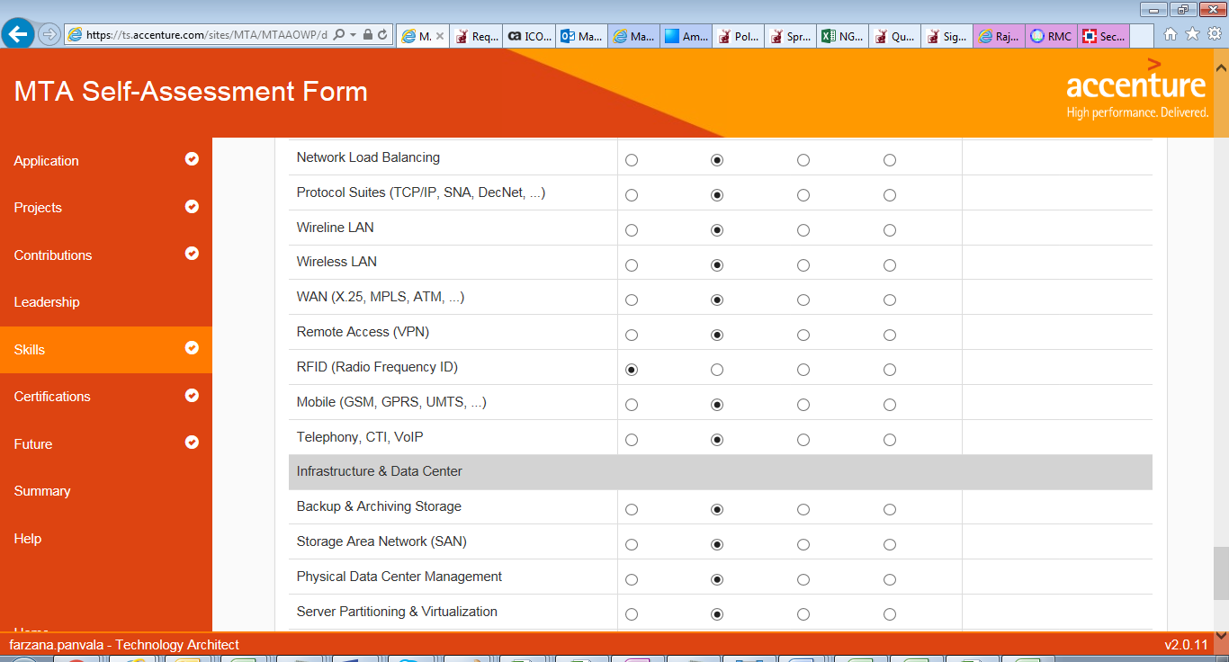

[Manik] its ok to be familiar (not less than that) incase u worked on it or can get some real time experience then mark to capable /expert level.

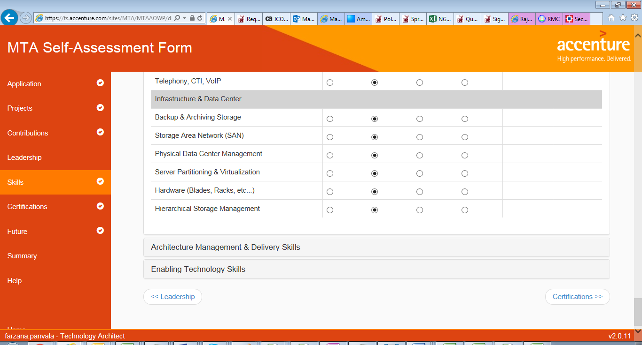

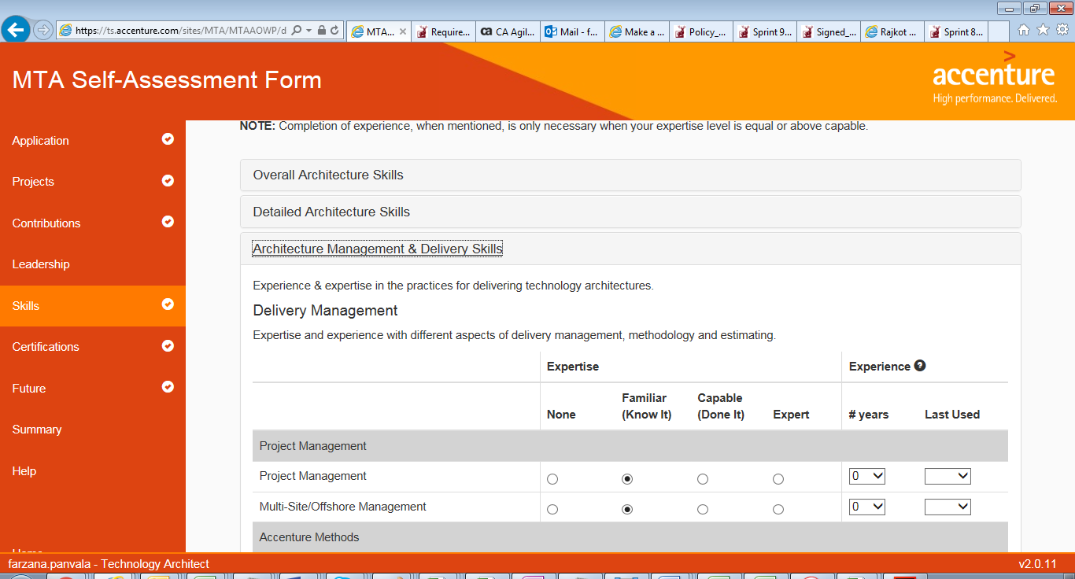

[Manik] Architecture mgmt and delivery skills – mark it expert level (mostly) and not less than capable

All this info is available on Accenture delivery excellence portal

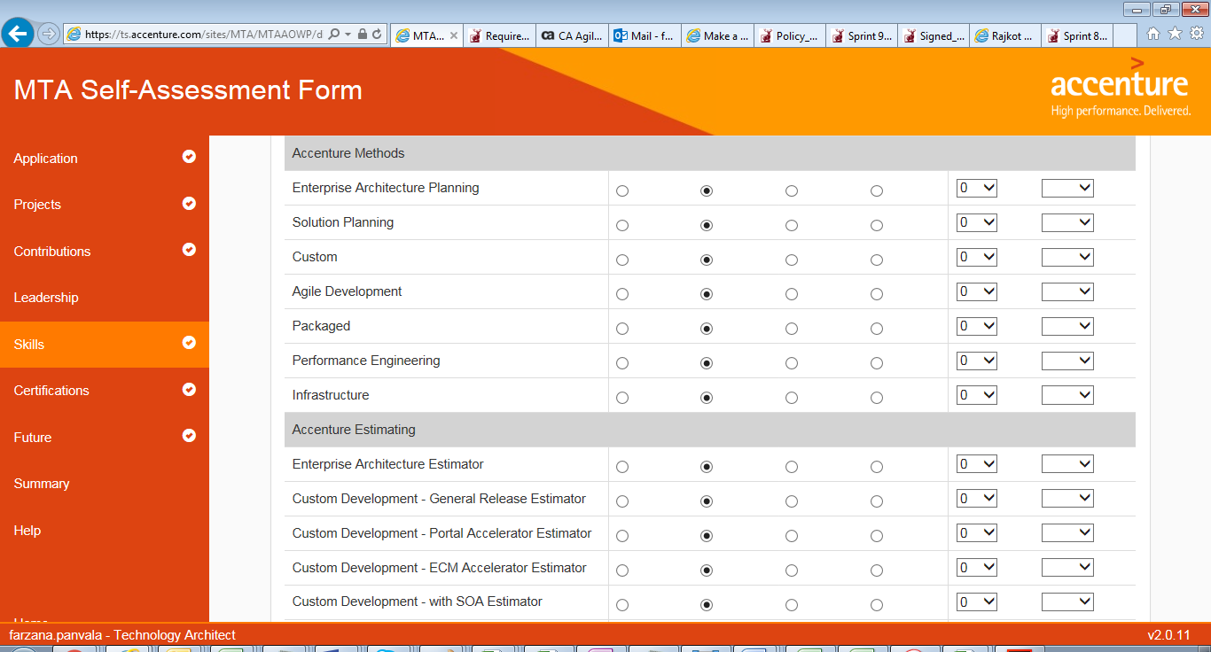

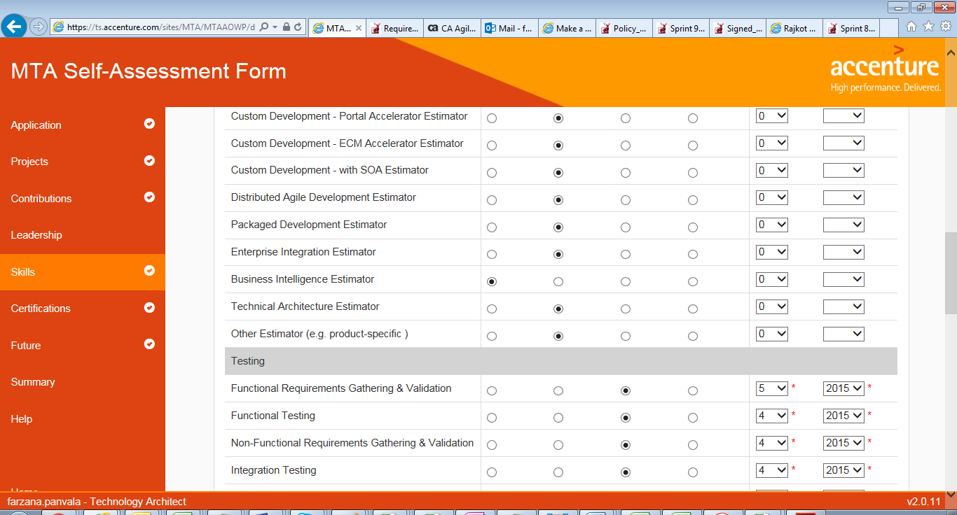

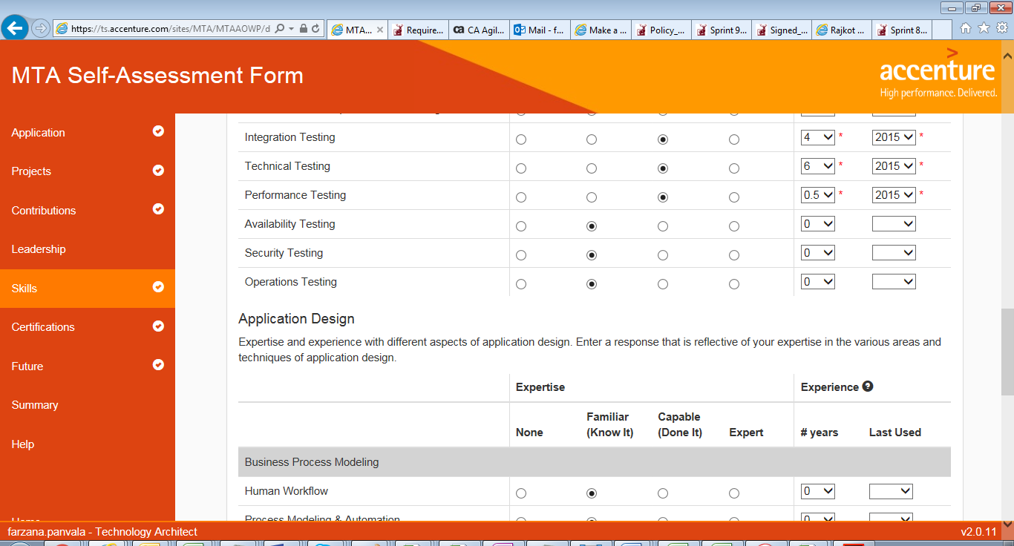

[Manik] improve ur score in Testing to expert level for functional, Application , Integration design , Technical testing…

Same applies for area like User Interface design , Business logic modelling, logical & physical data modeling.

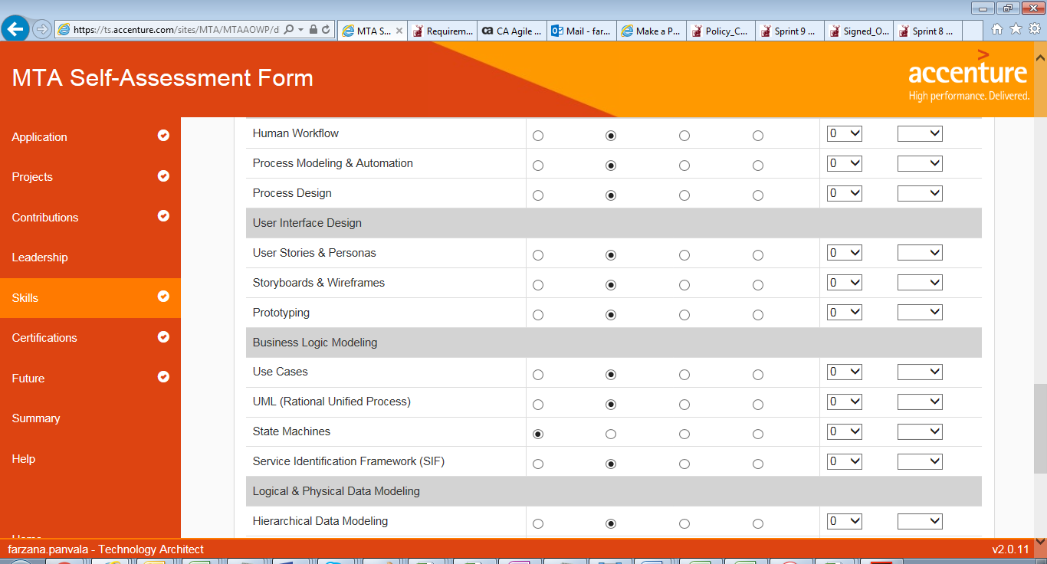

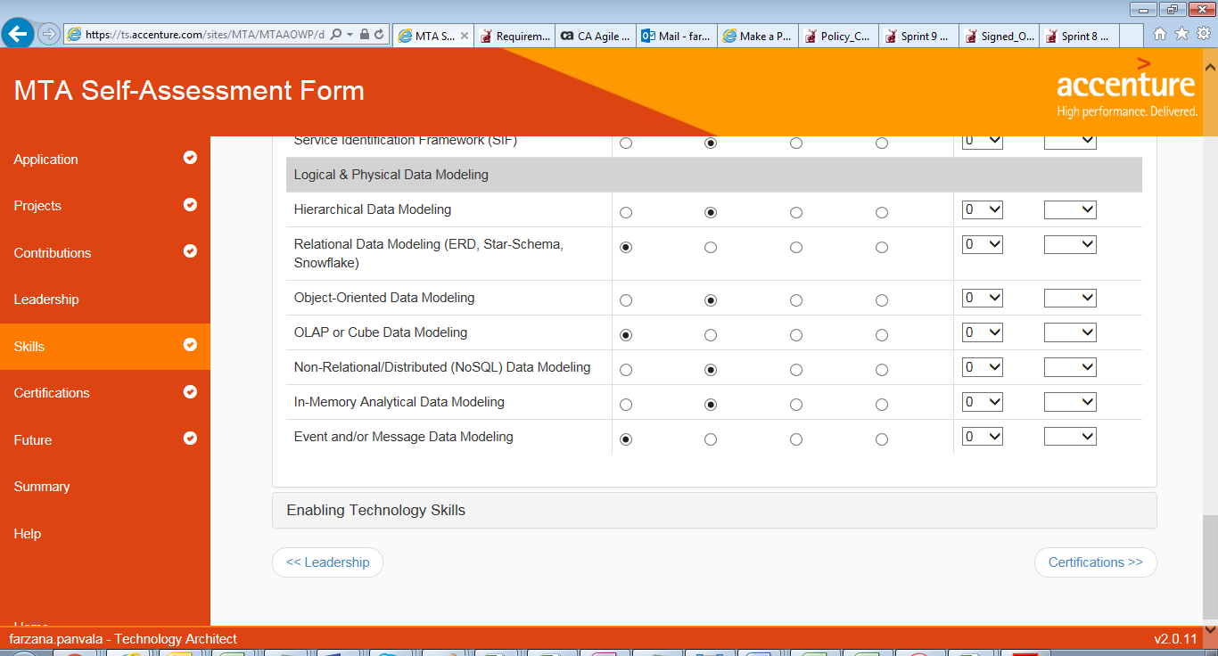

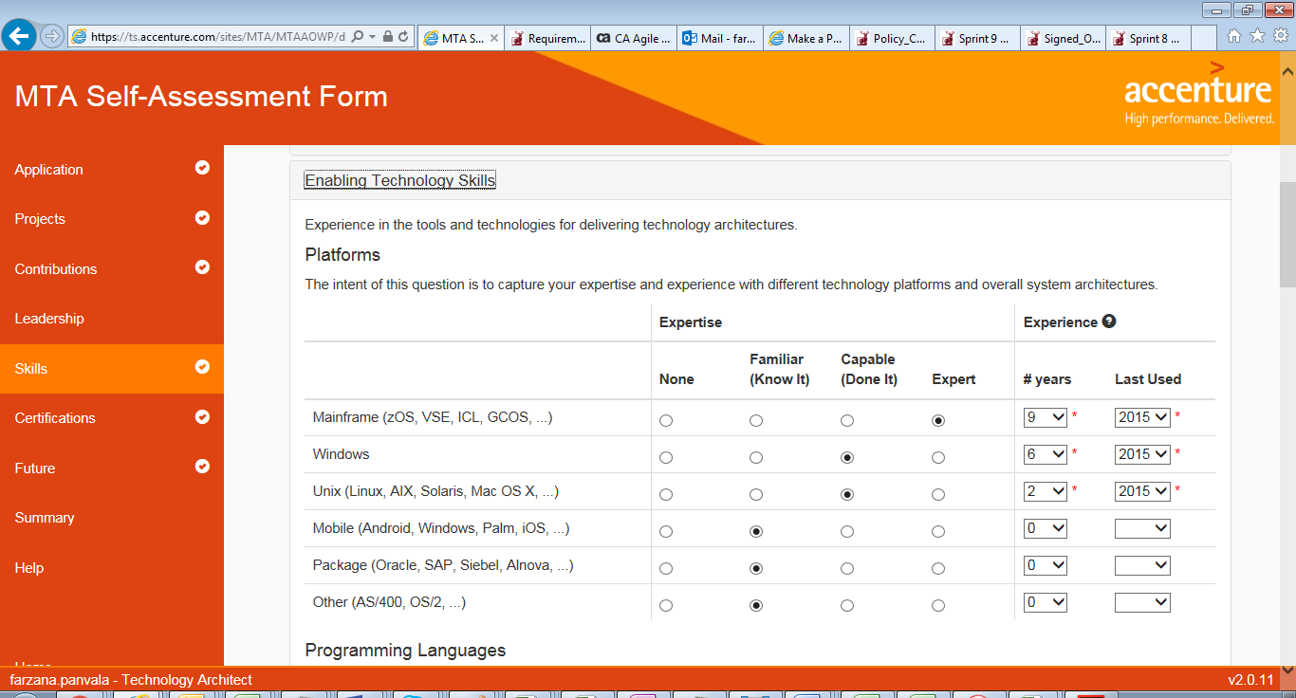

[manik] above snapshot looks ok

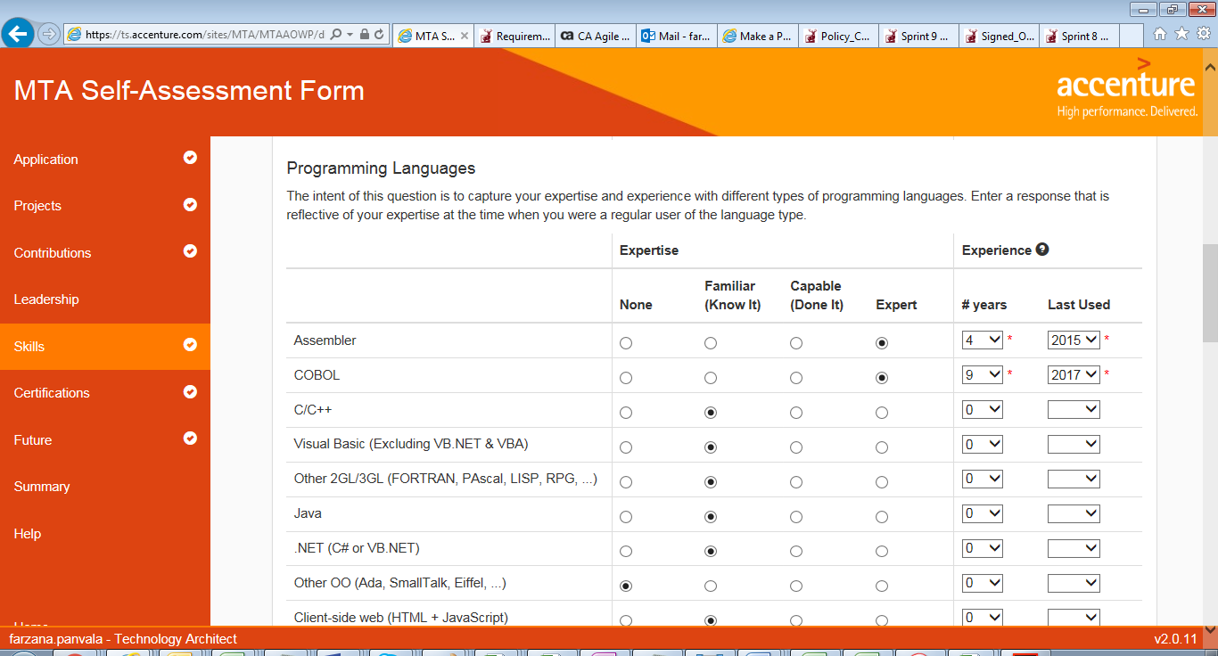

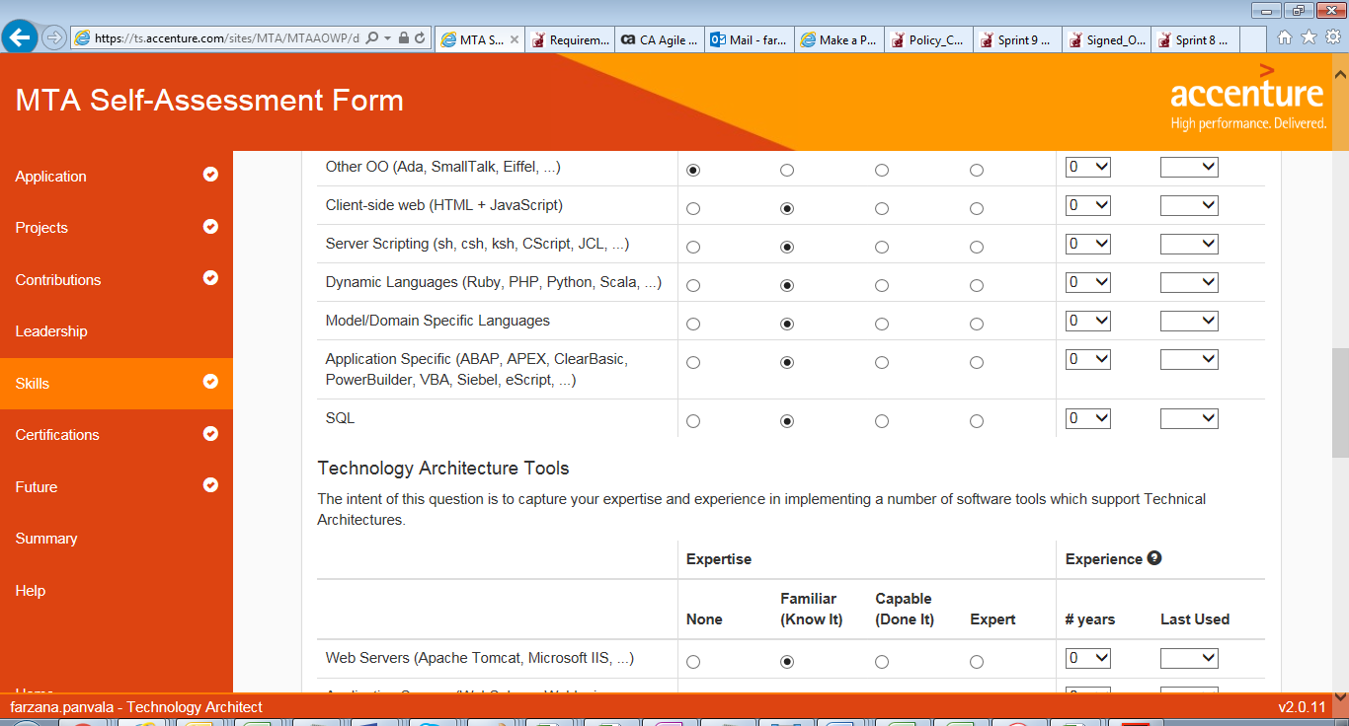

[Manik] try improve ur score on Technology Architecture tools by reading about it they are custom products mainly used for J2EE applications development/deploy.

Below 3 slides /snapshot – read about each item and try to gain knowledge – they all are theoretical concepts and should be easy to understand.

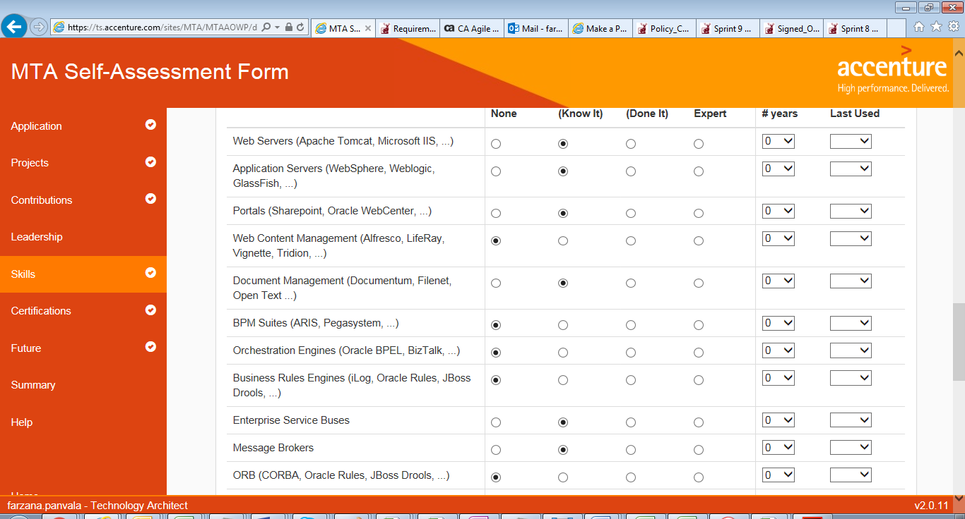

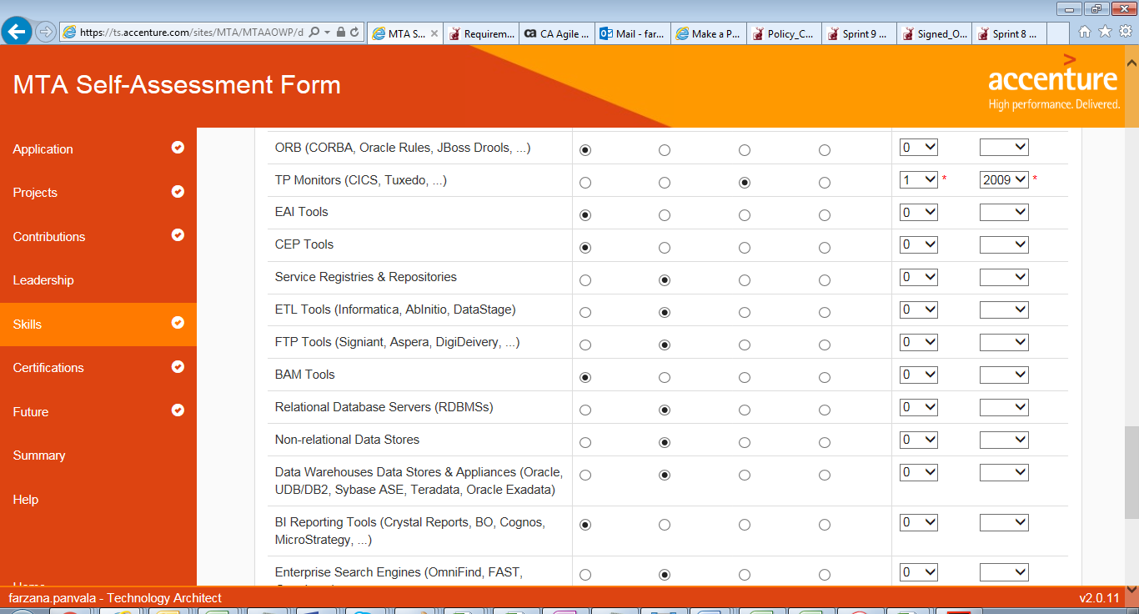

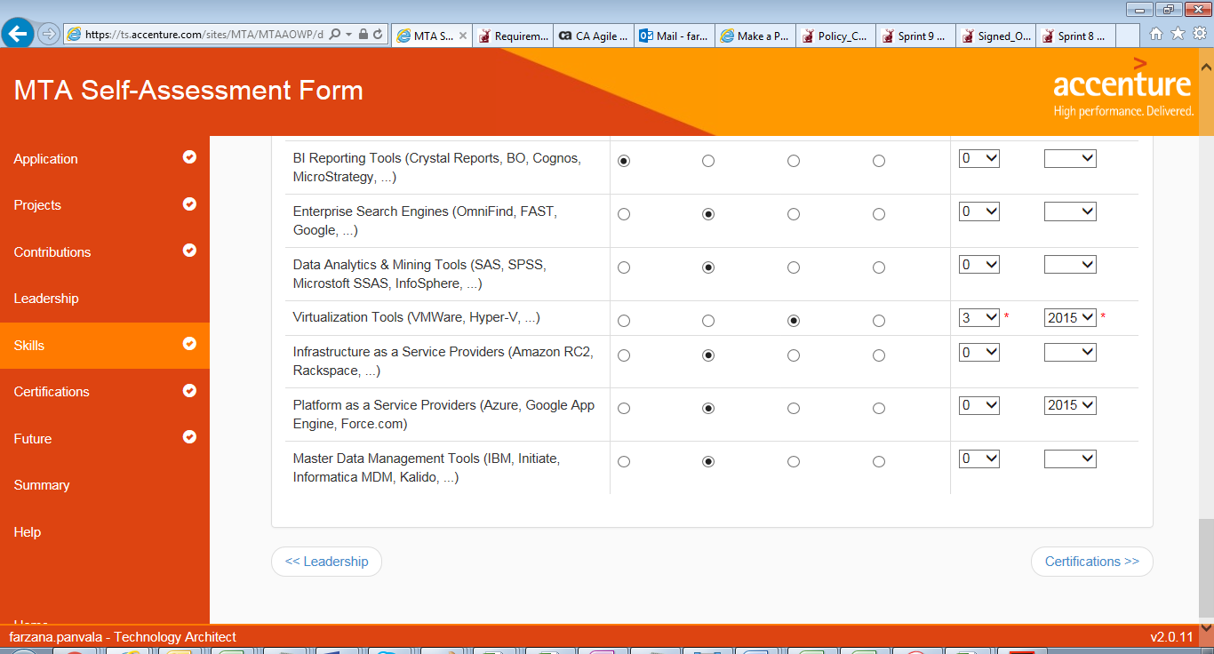

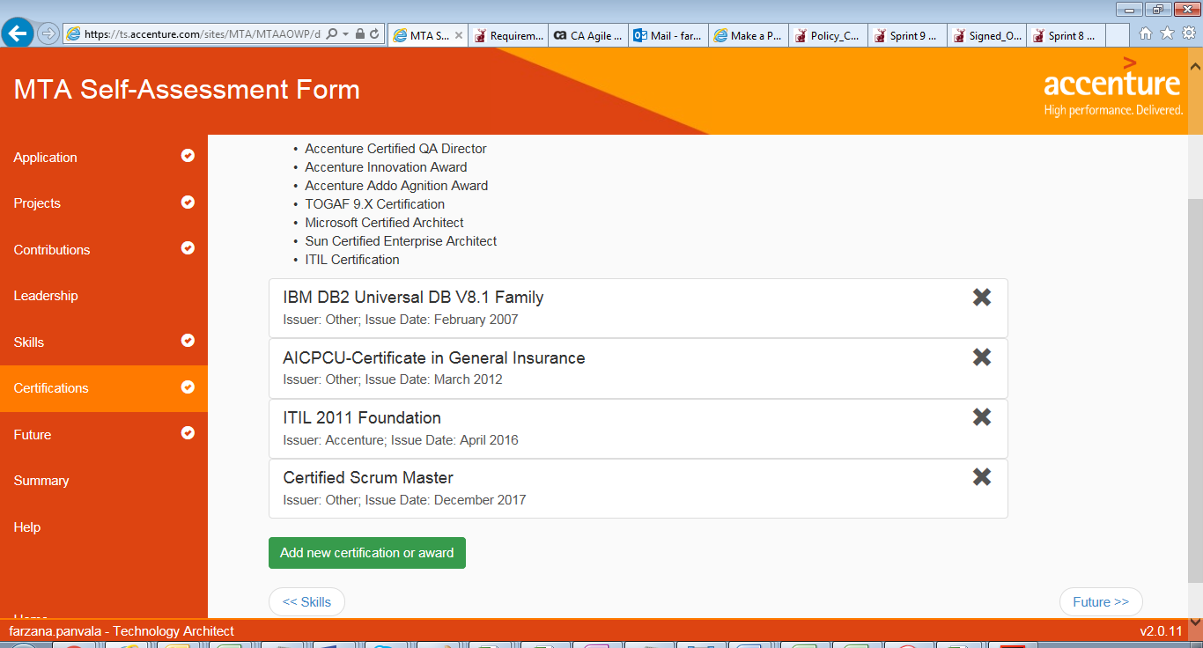

[manik] certifications are well covered